***Scanning Activity***

* How many hops from your machine to your assigned website?

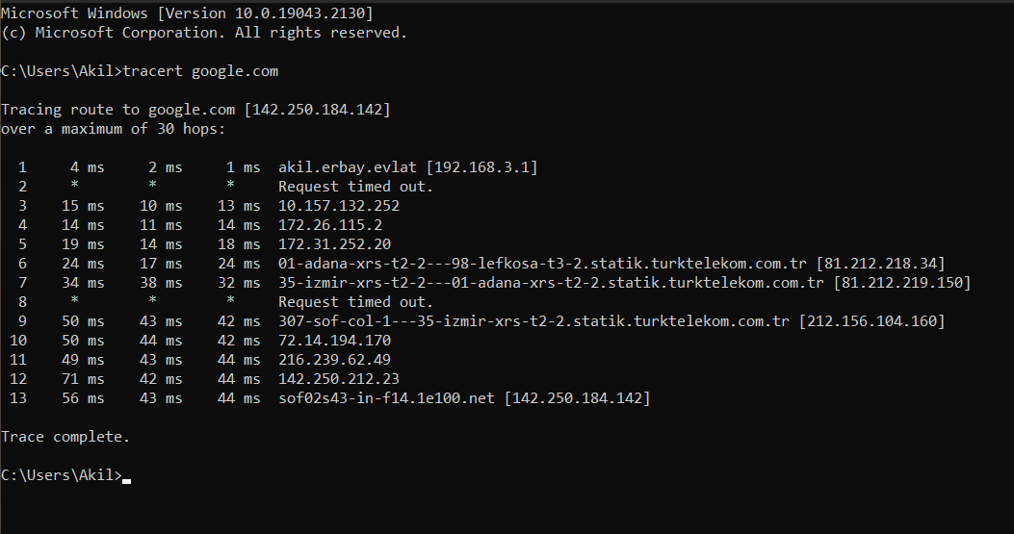

* Which step causes the biggest delay in the route? What is the average duration of that delay?



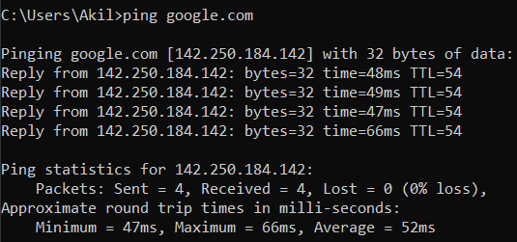

* What are the main nameservers for the website?

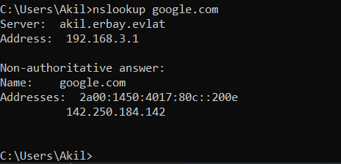

* Who is the registered contact?

Turktelekom.com



* What is the MX Record for the website?

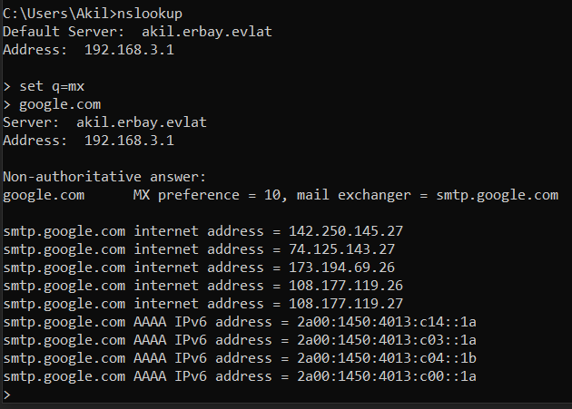

* Where is the website hosted?

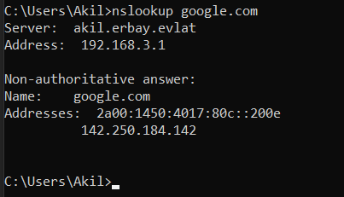

***Reflection:***

* Did you have any issues or challenges with the scans?

At first I had problems using CMD commands

* How did you overcome them?

I found solutions by searching the internet in a short time.

* How will they affect your final report?

Although I had a hard time understanding it at the beginning, it was nice and interesting towards the end. It helped me a lot to learn CMD commands.